***This release and additional tables***

***of international statistics are***

***available on efama’s website***

***(***[***www.efama.org***](http://www.fefsi.org)***).***

## Worldwide Regulated Open-ended Fund Assets and Flows

**Trends in the Fourth Quarter of 2019**

Brussels, March 25, 2020 **–** Worldwide regulated open-ended fund assets increased by 3.1 percent to EUR 52.7 trillion in the fourth quarter of 2019.[1] Worldwide net cash flow to all funds amounted to EUR 808 billion, compared to EUR 622 billion in the third quarter of 2019.

The information presented in this report was compiled by EFAMA and the Investment Company Institute (ICI) on behalf of the International Investment Funds Association (IIFA), an organization of national investment fund associations. Statistics from 47 countries are included in this report.

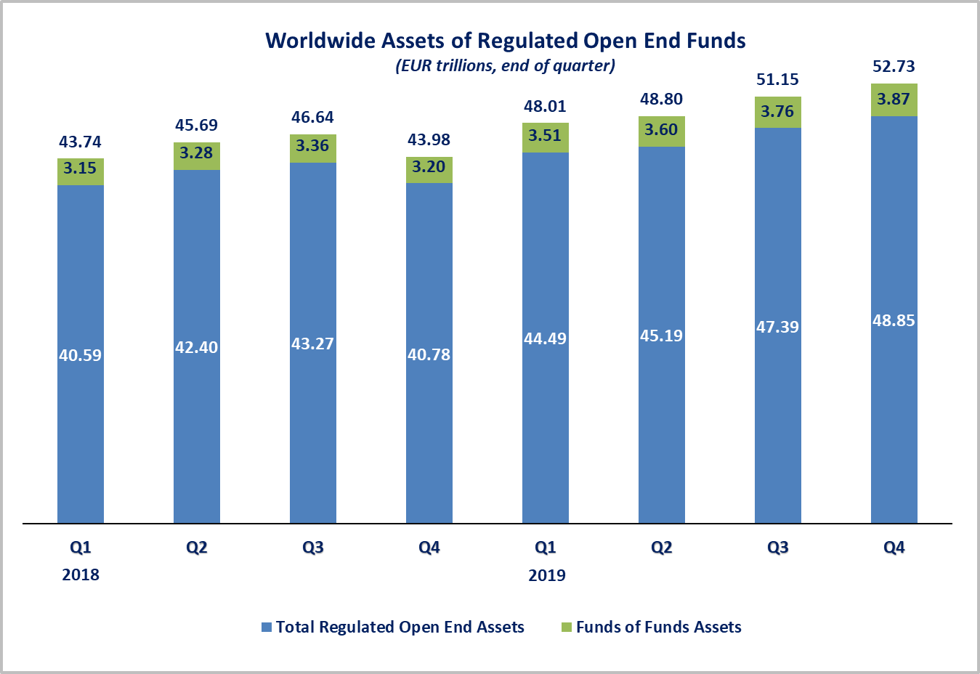

Measured in U.S. dollars, worldwide investment fund net assets increased to USD 59.2 trillion at the end of Q4 2019. This represented an increase of 6.4 percent. The following two graphs compare the net asset growth in the seven largest countries/regions.

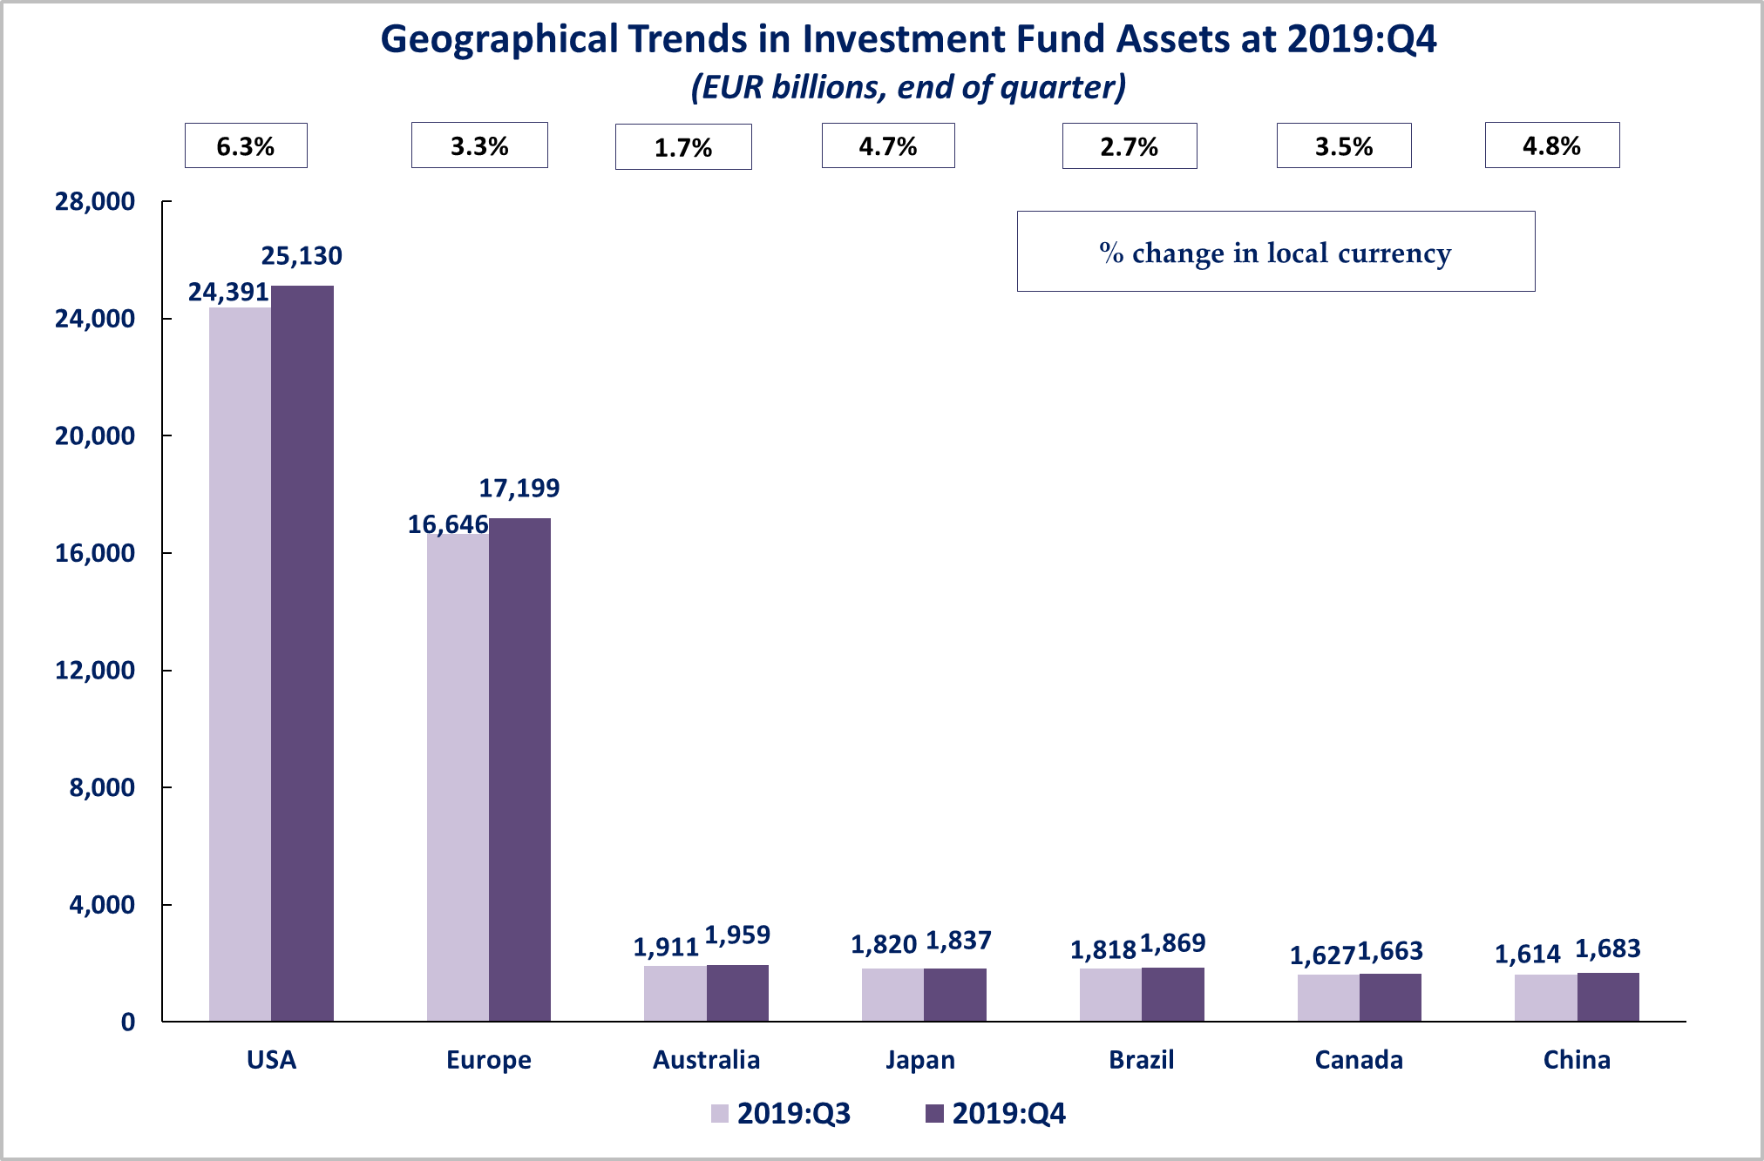



On a euro-denominated basis, worldwide equity fund assets increased by 5 percent to EUR 22.2 trillion at the end of the fourth quarter of 2019. Bond fund assets increased by 0.3 percent to EUR 11 trillion. Balanced/mixed fund assets increased by 2.7 percent to EUR 9.1 trillion. Money market fund assets increased by 1.5 percent to 6.2 trillion at the end of Q4 2019.



At the end of Q4 2019, 42 percent of worldwide regulated open-ended fund net assets were held in equity funds. The asset share of bond funds was 20.8 percent and the asset share of balanced/mixed funds was 17.2 percent. Money market fund assets represented 11.7 percent of the worldwide total.

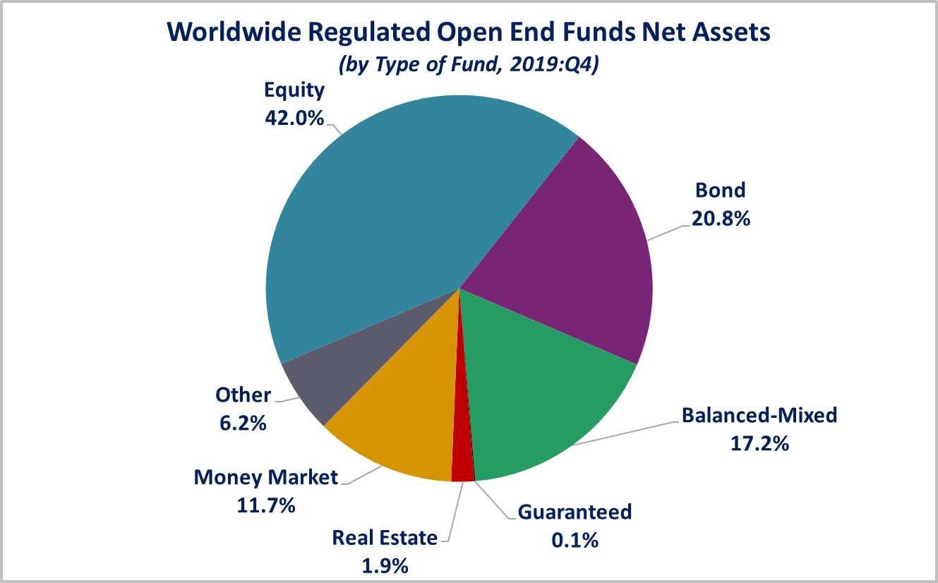

Looking at the worldwide distribution of investment fund net assets at end Q4 2019, the United States and Europe held the largest shares in the world market, with 47.7 percent and 32.6 percent, respectively. Australia (3.7%), Japan (3.5%), Brazil (3.5%), Canada (3.2%), China (3.2%), Rep. of Korea (1%), India (0.6%) and South Africa (0.3%) follow in this ranking.

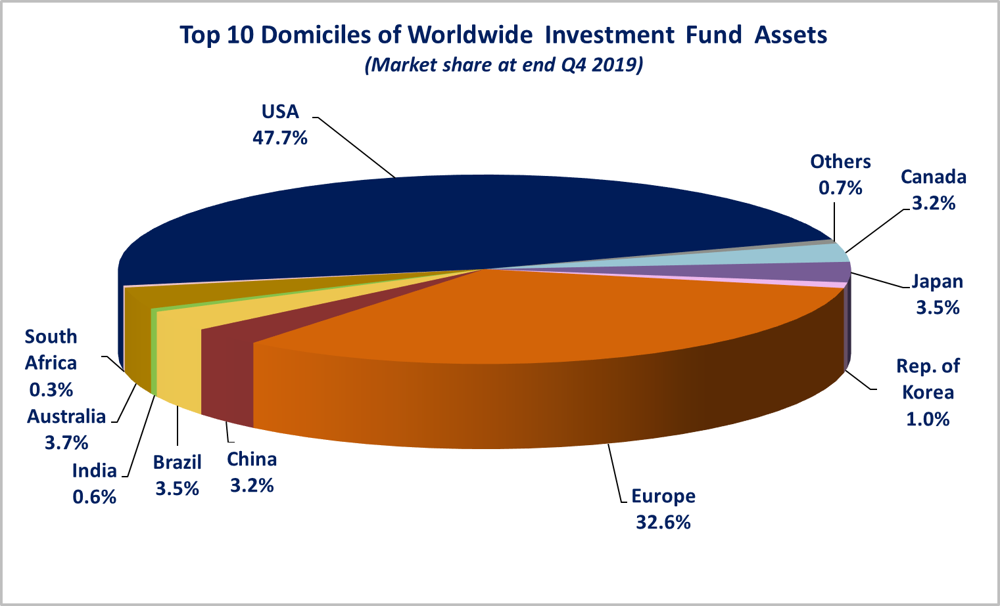

Overall, five European countries ranked among the top ten largest fund domiciles in the world: Luxembourg (with 8.9 percent of worldwide investment fund assets), Ireland (5.8%), Germany (4.5%), France (3.7%), and the United Kingdom (3.3%).

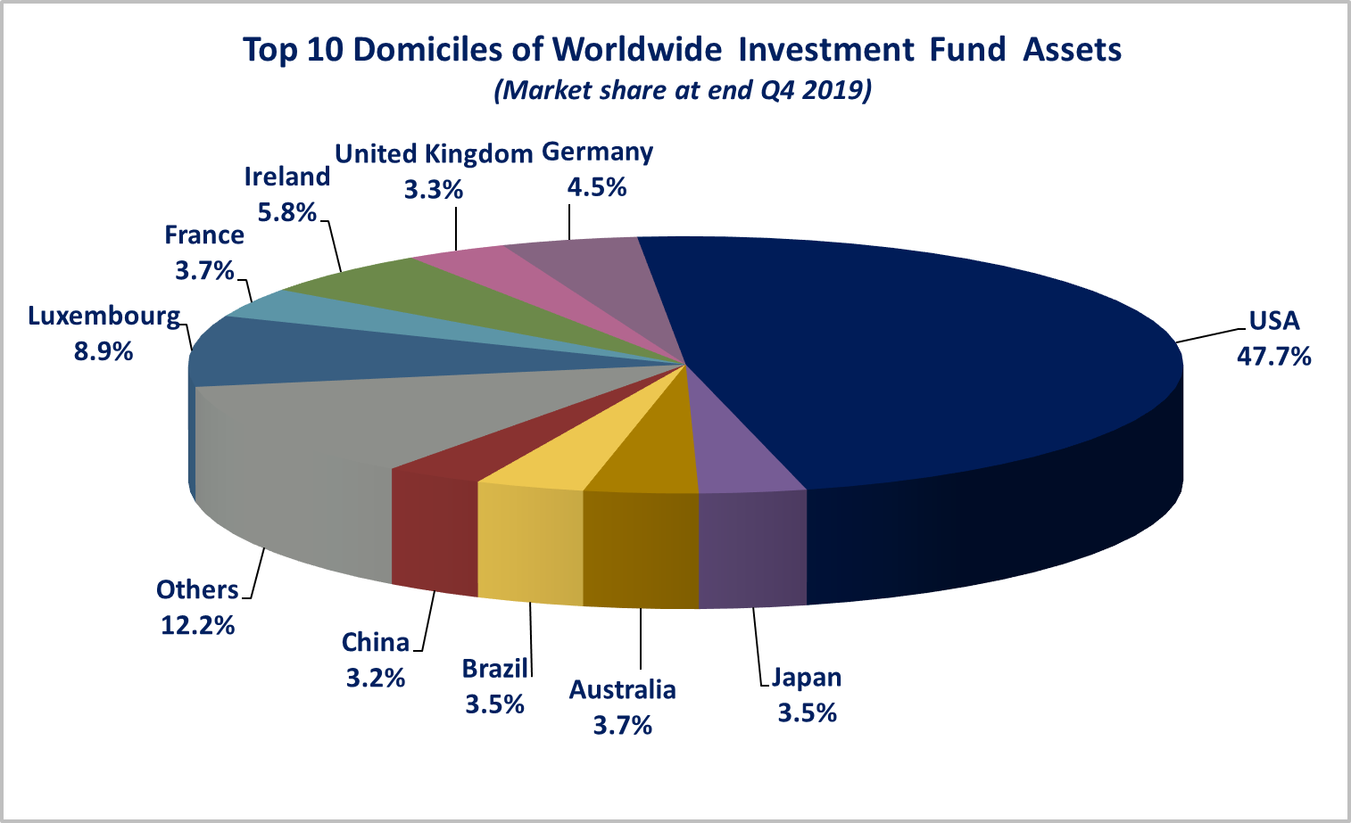Worldwide net sales of regulated open-ended funds increased to EUR 808 billion in the last quarter of 2019, from EUR 622 billion in Q3 2019. Long-term funds recorded net sales of EUR 549 billion, up from EUR 342 billion in the previous quarter. Globally, bond funds recorded net sales of EUR 234 billion, compared to EUR 245 billion in the previous quarter. Net sales of equity funds recovered strongly, from EUR 0.4 billion in Q3 2019 to EUR 134 billion in Q4 2019. Net inflows into balanced/mixed funds worldwide totalled EUR 120 billion, up from EUR 50 billion in Q3 2019. Net sales of money market funds amounted to EUR 259 billion in the fourth quarter of 2019, compared to EUR 279 billion in Q3 2019.

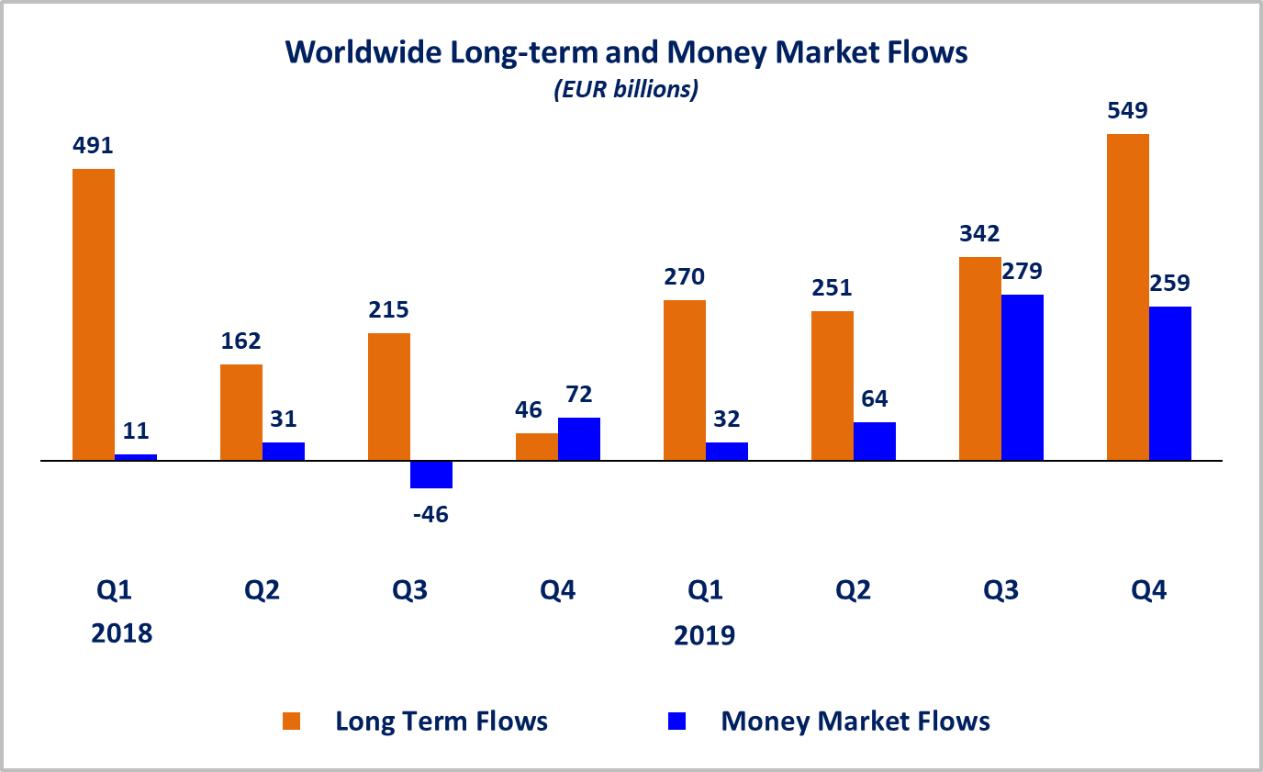

Net sales of regulated open-ended funds reached EUR 394 billion in the United States, EUR 183 billion in Europe and EUR 83 billion in the other advanced economies[2] (of which net inflows of EUR 39 billion in Canada and 27 billion in Japan). Emerging markets[3] recorded net inflows of EUR 148 billion, mainly driven by strong inflows in China (EUR 134 billion). All regions, except Europe, experienced an increase in net sales compared to Q3 2019.

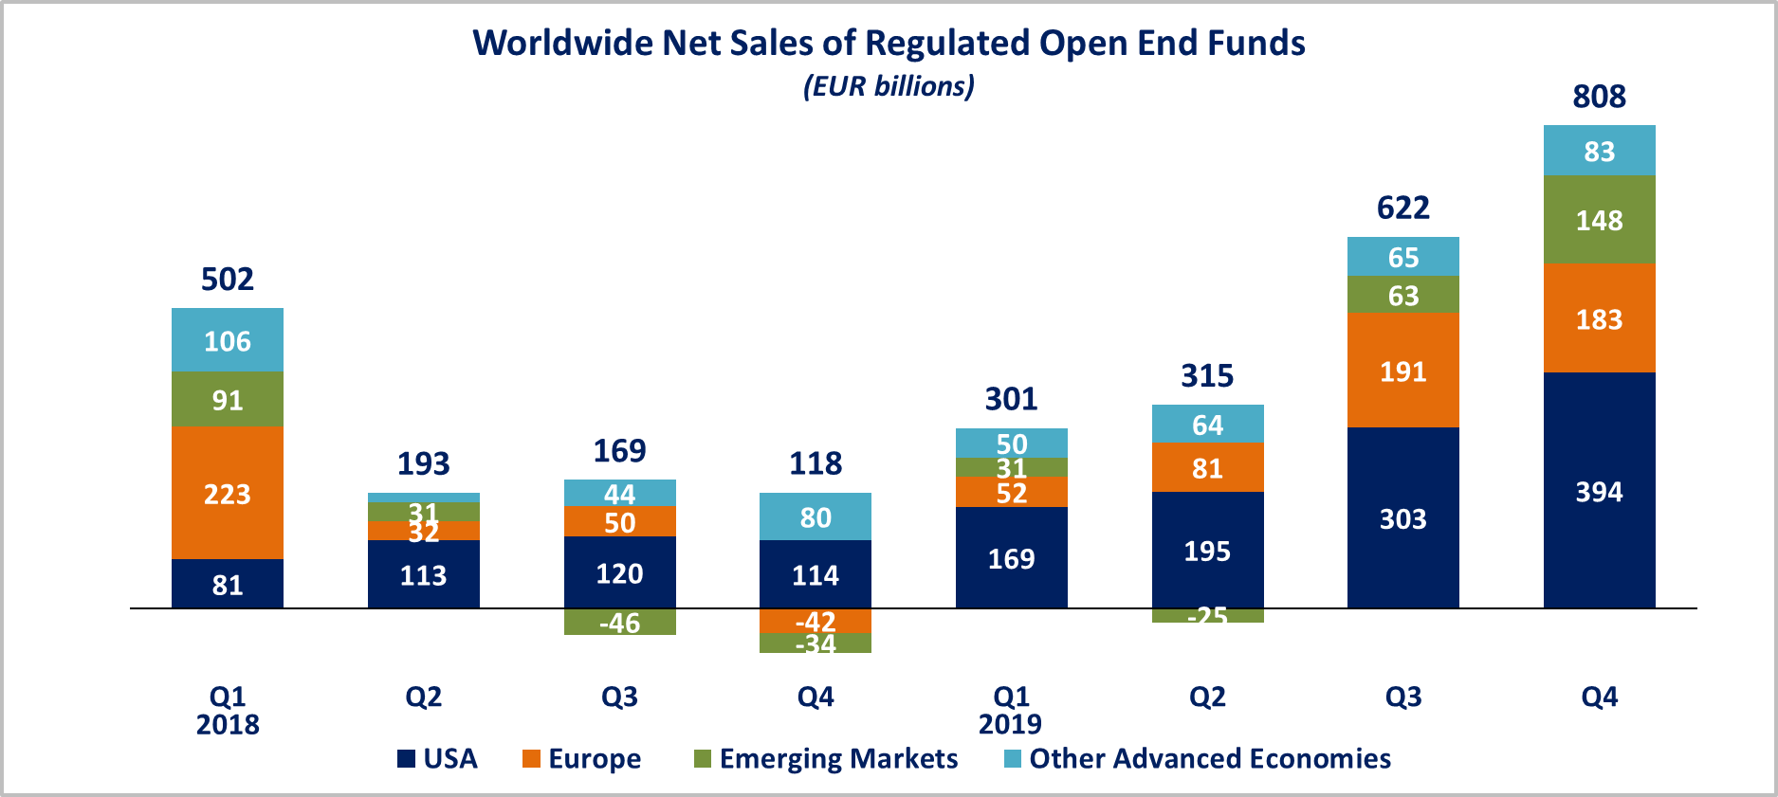

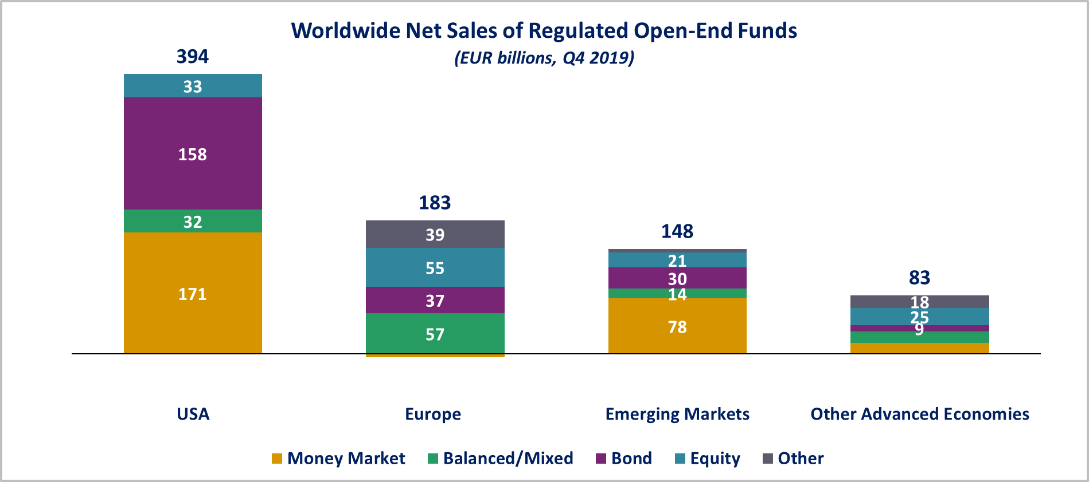

In Europe, long-term funds attracted net sales of EUR 188 billion, up from EUR 118 billion in the third quarter of 2019. Equity funds recorded net inflows of EUR 55 billion, compared to net outflows of EUR 11 billion in Q3 2019. Bond funds recorded net inflows of EUR 37 billion, compared to net inflows of EUR 82 billion in the previous quarter. Net inflows into balanced/mixed funds amounted to EUR 57 billion, up from EUR 30 billion in Q3 2019. Money market funds recorded net outflows of EUR 5 billion, compared to net inflows of EUR 73 billion in the third quarter of 2019.

In the United States, long-term open-ended funds recorded net sales of EUR 222 billion, up from EUR 89 billion in Q3 2019. Equity funds recorded net inflows of EUR 33 billion, compared to net outflows of EUR 37 billion in the previous quarter. Net sales of bond funds increased from EUR 121 billion in Q3 2019 to EUR 158 billion in Q4 2019. Balanced/mixed funds registered net inflows of EUR 32 billion, compared to net outflows of EUR 3 billion in the third quarter of 2019. Net sales of money market funds amounted to EUR 171 billion, compared to EUR 213 billion in the previous quarter.

**Regional Summary Table by Type of Fund, Q4 2019**



1. All data presented in this report include funds of funds, exchange-traded funds and institutional funds.
2. Other advanced economies are countries thus defined by the International Monetary Fund, based on criteria such as per capita income level and the degree of integration into the global financial system, excluding the US and the countries included in the Europe aggregate. Data is not available for all advanced economies. Other advanced economies include Australia, Canada, Japan, Korea, New Zealand and Chinese Taipei (Taiwan).
3. Emerging markets are countries thus defined by the International Monetary Fund. Data is not available for all emerging markets. The following countries are included: Argentina, Brazil, Chile, China, Costa Rica, India, Mexico, Pakistan, the Philippines, South Africa and Trinidad & Tobago.